**Experiment No. 10**

**Aim: Implementation of simple socket programming for message exchange between server and client.**

**Code:**

**Server Side:**

import socket

host = '127.0.0.1'

port = 6000

s = socket.socket()

s.bind((host, port))

s.listen(1)

print("Waiting for connection...")

c, addr = s.accept()

print("Connection Established!")

print("Client Address:", addr)

while True:

    try:

        print()

        data = c.recv(1024)

        d = data.decode('ascii')

        print("Client:", d)

        print()

        x = input("Enter New Message: ")

        y = x.encode('ascii')

        c.send(y)

    except KeyboardInterrupt:

        print()

        print("Connection Terminated!")

        break

**Client Side:**

import socket

host = '127.0.0.1'

port = 6000

s = socket.socket()

s.connect((host, port))

print("Connection Established!")

while True:

    try:

        print()

        x = input("Enter New Message: ")

        y = x.encode('ascii')

        s.send(y)

        print()

        data = s.recv(1024)

        d = data.decode('ascii')

        print('Server:', d)

    except KeyboardInterrupt:

        print()

        print("Connection Terminated!")

        s.send("Connection from Client terminated!".encode('ascii'))

        break

**Output:**

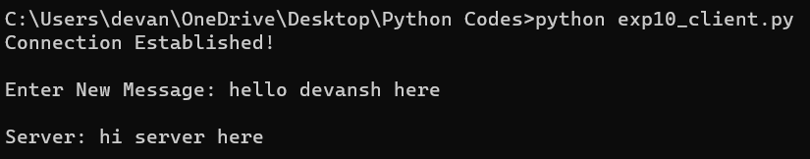**Client**

**Server**

